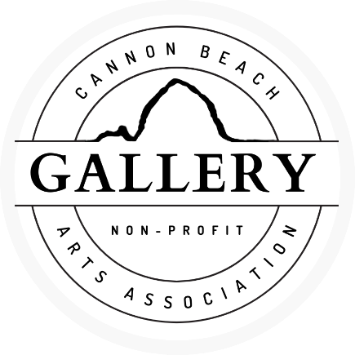
Consignment/Exhibit Artist Agreement
“IN THE MOMENT”
We are excited to represent you and your artwork in our nonprofit gallery within the vibrant community of Cannon Beach. This agreement establishes the Gallery’s arrangement with you, the Artist. We look forward to a mutually beneficial relationship.
1. Duration: The consignment period begins and ends on the two dates indicated in the top section of the attached inventory sheet. Mutually agreed extensions or additional consignments will be documented with new inventory sheets that represent the specific works and the new agreed upon begin/end dates.
2. Transfer of Artwork: The Artist is solely responsible for delivering their work to the Gallery on or before one week of this date: ___Mar 13, 2024. The jury process will take place Mar 13, 14, 15. Unselected artists must retrieve their work no later than this agreed upon date: __Mar 22,2024. Selected artists need to retrieve their work after April 28, 2024. Cost of transfer to/from the Gallery is the responsibility of the Artist. All work should be delivered as ‘gallery-ready’ (e.g., signed/labeled, ready to hang, display cases for jewelry/cards).
***Artwork needs to have a price, title, medium, and artist name on the back, if it does not it will be rejected.
3. Retail Price/Discounts: Artist will list the retail price for each work on the inventory sheet. If the Artist is willing to discount any work(s), the specific discount percentages are to be filled in by the Artist per work on the inventory sheet.
4. Commission Payments: The Gallery pays 50% (non-member) or 60% (member) commissions to their Artists. You can become a member through our website. Payments will be made within 60 days following the sale of any work. If approved for discount and sold below retail price, commission is calculated on the discounted price. Shipping, if required when purchased from the Gallery, is not the Artist’s responsibility and will not affect the Artist’s commission.
5. Damage and Loss: The Gallery will take reasonable precautions to protect consigned works from theft or damage and is insured against loss. If loss or damage occurs, the Artist will be compensated at the above applicable non-member/member commission rate based on the retail price documented in the inventory acceptance sheet. Following compensation to the Artist, the work becomes the property of the Gallery.
6. Representation: The Artist represents that submitted work is original and the copyright belongs to the Artist. The Artist agrees that representations of their work can be included on the website or other Gallery materials during the consignment/exhibit period.
Start Date: _________ Gallery Representative: ______________________________________________
Artist Signature: ____________________________________ Legal Name (Printed): _____________________ ______
Artist Mailing Address: __________________________________________________________________
Phone: __________________________ Email: _______________________________________________
INVENTORY SHEET
Artist Name: _____________________________Phone: ____________________Email: ______________________________
Mailing Address:_________________________________________________________________Date:__________________

Inventory # (If applicable) | Title | Medium | Description | Price

